Cosc 385 - Theory of formal languages, theory, and automata

Spring 2024

Project 2

Problem Letter S

Warren Shakes

Function

My function is_suffix(suffix,word) takes in a suffix, which is an affix occurring at the end of a word, base, or phrase. My function takes in two variables, one being the suffix, and the other being the word which you are testing, and returning True if the word has the suffix in it, otherwise false if the word does not have the suffix in it.

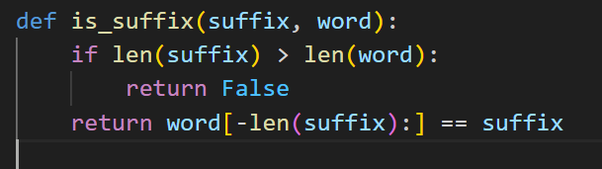

Program

My program takes in two input statements, that being the word and the suffix, and then it inputs those two variables into the function.

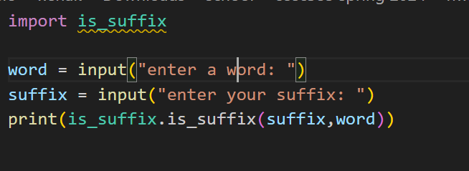

Examples

